Lab and Simulation Assignment

TME202

Report

Students: AdiptaLaha

Fikri-Farhan Witjaksono

Jan-Hendrik Dürkop

Group: K

# Introduction to the Task

The task, which is solved throughout this report is the following:

*“You are working in a crash safety division at a small car company that produces cars for the upper market segment. Your product uses a car platform that is already developed for a budget car. Your car will be fitted with entertainment systems, extra noise insulation, better anti-whiplash seats etc. All this equipment will add mass to the car. What is the maximum car weight the existing design can support without encountering problems that the “car” front structure bottoms out? In the lab, the test device can accelerate the mass of the budget car to the desired velocity but not the car with additional mass, i.e. you need to design your tests with the budget “car” in a way so that you can answer questions about the performance of the heavier “car”. You should define what the limit is for bottoming out.”*

The objective of this task is to find the mass of the vehicle, at which the front structure is bottoming out. Bottoming out means, reaching the maximum possible deformation. For solving this task, the limit for bottoming out has to be set. In this case, we do this after our tests in the laboratory. The first step for solving this task, is to do different tests in the lab. For this we made a test-matrix (see table 1). After that, a simulation model had to be chosen in the benchmark assignment, which was followed by the in-house task. In that task, the right thickness of the can had to be found in order to make the simulation results as accurate as possible compared to the tests in the lab. Finally, the task could be solved with adding mass in the simulation model and doing some more simulations.

# Lab procedure and lab results

Table 1: Test-Matrix

|  |  |  |  |  |
| --- | --- | --- | --- | --- |
| **Test** | **Distance**  **[cm]** | **Added Mass [kg]** | **Velocity**  **[m/s]** | **Length (post) [cm]** |
| 1 | X | 6 | 2.94 | 7.4 |
| 2 | X-30 | 4 | 2.7 | - |
| 3 | X-20 | 4 | 2.81 | - |
| 4 | X-5 | 4 | 2.9 | - |
| 5 | X-5 | 4 | 2.9 | 7.6 |
| 6 | X-10 | 2 | 2.94 | - |
| 7 | X-10 | 2 | 2.94 | 8 |

The goal of doing the tests was, to have the same velocity at the start of the deformation, while varying the mass of the sled. We started with the maximum added mass of 6 kg at the maximum distance possible to the load cell (distance X). We calculated the velocity with the data of the light gate. This test showed a deformation of 6.8 cm with an added mass of 6 kg. The initial length of the can was 14 cm. The tests 2, 3 and 4 were pre-tests for finding the right distance to the load cell in order to have the same speed at the load cell as in test 1. Test 5 was our second test, with a resulting deformation of 6.4 cm with an added mass of 4 kg. Test 6 was a pre-test for test 7, which was our third actual test. That test showed a deformation of 6 cm with an added mass of 2 kg.

The test plan we developed before the lab was the other way around. We planned to start with the lowest mass possible and increase it with every test, while keeping the velocity constant. We came up with the idea that this procedure shown in table 1 is the most effective one.

# Benchmark and in-house

The benchmark task was about finding the right simulation model, which we will use in the following simulations. The things to look at for finding the most promising simulation model were the computation time, the hourglass energy, the energy balance, the contact forces and the acceleration of the can. Regarding the computation time, the 1mm-mesh model would take around 10 hours, which is around 9 hours longer than the 2mm-mesh model. So the 1mm-mesh model was not an option. We now compared the 2mm with the 4mm-mesh model, because it could be shown that the 10mm and the variable-mesh model were too inaccurate, because of the high hourglass energy. By looking at the contact forces, accelerations, length of the simulation and the “look” of the deformation, it could been shown that choosing the 2mm-mesh model is the most accurate one, while maintaining an acceptable computation time. The deformation of the can looked similar to the deformation captured with the camera during the lab tests. Also the duration of the simulation and the resulting position of the sled of the 4mm-meshwere too inaccurate compared to the 1mm-mesh model. Also the behaviour of the contact force and the acceleration showed that the longer computation time of the 2mm-mesh model were worth compared to the 4mm-mesh, because of the amount of increasing accuracy.

The next-step would be the in-house part of the assignment. In this assignment, we use the 2mm mesh that is defined as the most accurate model from benchmarking result and simulate the model in LS-DYNA. Initially, we try a couple of can thickness values randomly and find out that the values that are having the maximum deformation which is similar to the experimental values are hard to obtain. After that, by defining the mini design of experiment which starts from the value of 1 and with decrease in increment of 0.05, we keep trying the simulation on and on until we stuck in 0.25 mm and 0.20 mm that seems closest to the desired maximum deformation.

After several times of trial and error in finding the right value, at the end we get the desired value of can thickness of 0.23 mm where the difference between maximum deformation in experimental and simulation value was about 1 mm.

So after choosing the thickness of the can as 0.23 mm. We need to validate it, to see whether the thickness that we chose is right. So we plot a graph to check the behavior of force with respect to time for both the experimental and the simulation.

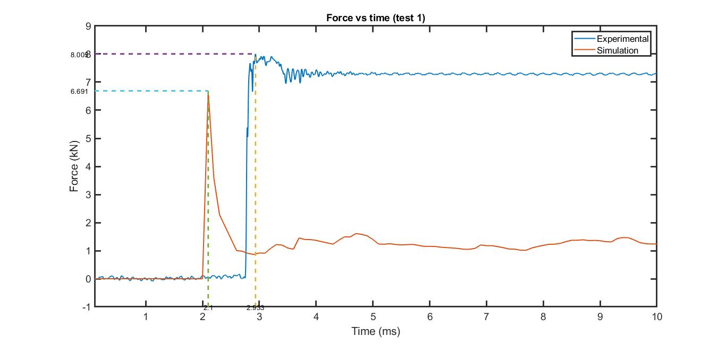

Fig. 1. Force vs Time

So here we are comparing the behavior of the forces for both experimental and the simulation with respect to time. We can see that the forces of the two graphs are similar before the crash happens .our main concern about this force plot is the behiviour of the curve after the crash happens. After the crash the experimental curve maintains a constant amount of force with respect to the time for a longer period of time whereas the force in the simulation curve first decreases then maintains a constant force , this indicates that the force imparted to the drivers compartment is less ,as the magnitude of the force decreases. So the simulation curve gives us a desired output. The experimental force vs time curve is plotted from the camera data. After the force reaches its maximum value, it goes on as a constant value and then decreases and then again keeps a constant value. So since it is an experimental data, the environmental conditions has an impact over the readings recorded, that is the reason for the constant force value after the impact.Since both the plots shows us a similar behavior so we can conclude that the thickness we choose is the correct one.

After confirming the thickness as 0.23mm, we simulate for each different test conditions where we have 6 kg, 4 kg and 2 kg of added mass in test 1, 2 and 3 respectively.

The result of the simulation are pretty similar with experimental value with the minimum deviation to be 0.3 mm and the maximum deviation to be 1.1 mm. The deviation of 0.3 mm is found through the test 1 condition where we used the added mass of 6 kg, thus using the total mass of 35 kg if we added initial sled mass of 29 kg.

Table 2: Experimental and Simulation Data Comparison

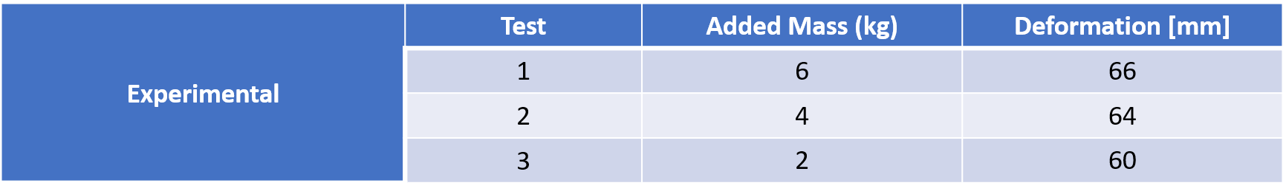

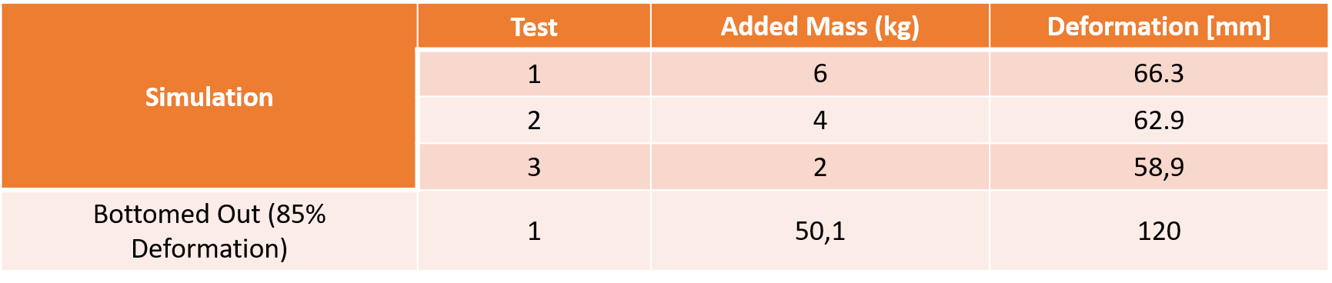

The figure 2 below shows the plotted deformation and added mass value that we obtained from the simulation and experiment.

Fig. 2. Deformation vs Added Mass

After plotting Fig. 2. as our deformation vs added mass plot, we also plot the deformation vs time in the simulation for each test in addition to the bottoming out condition. The result of the plot is shown below in Fig. 3. If we observe this plot, the 3 plots of test 1, test 2 and test 3 looks really similar in appearance since the added mass between them is not really significant compare to the added mass used for the bottoming out simulation.

Fig. 3. Deformation vs Time in the Simulation

Fig. 4. Velocity vs Time in the Simulation vs Experimental

By using the same model as in Test 1, we plotted the velocity- time graph and compared it with the experimental result from the camera. However, we did not get the desired validation we need for the velocity. Hence, we cut the part that is irrelevant to the simulation model, the data after 140 ms and before 80 ms are excluded in the yellow plot. However, we include the original uncutted version of the experimental data as a comparison. By this, we could confirm that there is some degree of incoherence in our simulation model compare to the real experimental situation. But Generally, the model is valid with some degree of incoherence.

Results (Actual bottoming out)

Since the first test has the lowest deviation value compare to the other test conditions, we decided to use it as a basis to find the bottomed out deformation. We defined the can bottomed out deformation to be 85% of the maximum deformation because we observed that when we use 80% deformation as our target, the can did not look bottomed out enough. Moreover, when we try to reach 90% of deformation, the required added mass seems to be really high compared to if we used 80% deformation as our target. Therefore, we decided to use 85% of maximum can length deformation as our bottomed-out deformation point.

Next, by using the previously found can thickness of 0.23 mm, we keep adding mass in the increment of 5 kg in order to reach the desired can bottoming out deformation. After many times of trial and error, we find that the added mass of 50,1 kg corresponds to about 85% of can deformation (initial can length = 140 mm, bottoming out deformation = 85%, the simulation results = 120 mm).

Simulation Result Deformation(%)= $\frac{simulation results deformation[mm]}{initial can length[mm]} x 100\left[\%\right]$ = $\frac{120 [mm]}{140 [mm]} x 100 [\%]$ = 85.71 [%]

Since 85.71 % of can deformation can be rounded down to 85 % and it is the closest that we can get to the 85 % target value, we decide to use this added mass of 50.1 kg for the bottoming out deformation, thus using a total mass of 79.1 kg including the sled mass.

Since it is not possible to carry out bottoming out (85% deformation) in our lab, we use simulation tools to create a bottoming out of our front structure. Since the graph in the figure 3 does not follow the experimental results exactly and there is a slight difference in the slope, we can assume that our result is not the exact solution. But since the difference is quite small, we can say that our result is a good estimation for the solution of this task.